VPC-01 tasks
- Create VPC with 2 private and 2 public subnets.
Ans: First login to aws consol and search for vpc and create one vpc instance 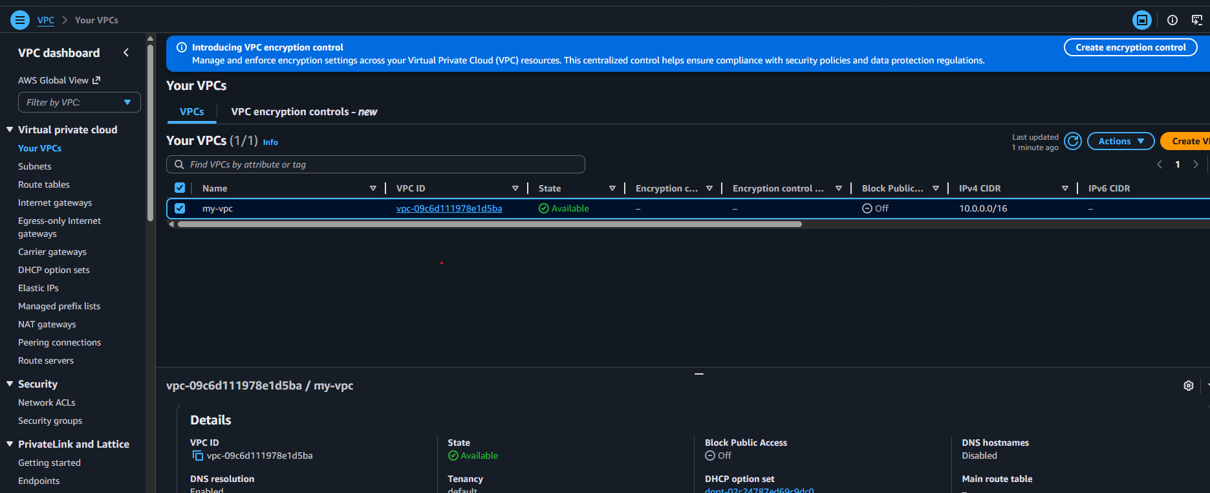

Once the vpc is been created click on subnets and create the subnets by selecting created vpc added public and private region given the cidr range for vpc subnets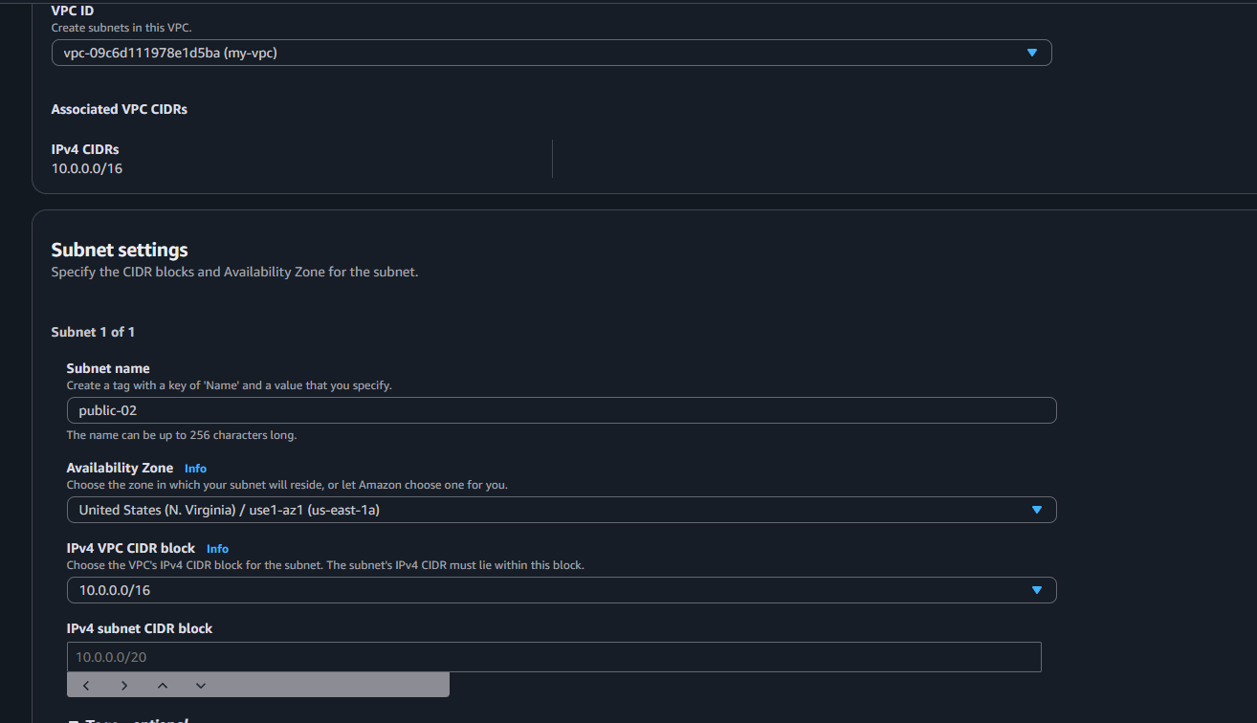
Then created 2 public subnets and 2 privates subnets 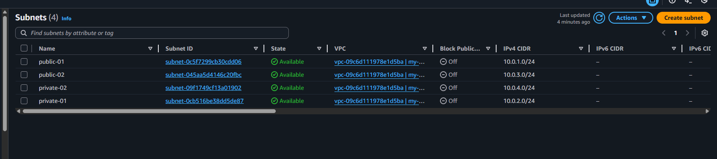

2 :Enable DNS Hostname in VPC.
Ans: To able to enable hostname ned to click on settings bar and click on edit vpc settings and select vpc hostname and save the files 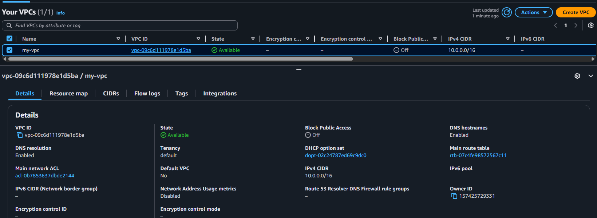

3 :Enable Auto Assign Public IP in 2 public subnets.
Ans: To able to assign auto public ip on our 2 public subnets need to select the public subnets and click actions and click on edit subnets settings and select the auto public ip assign and save the settings 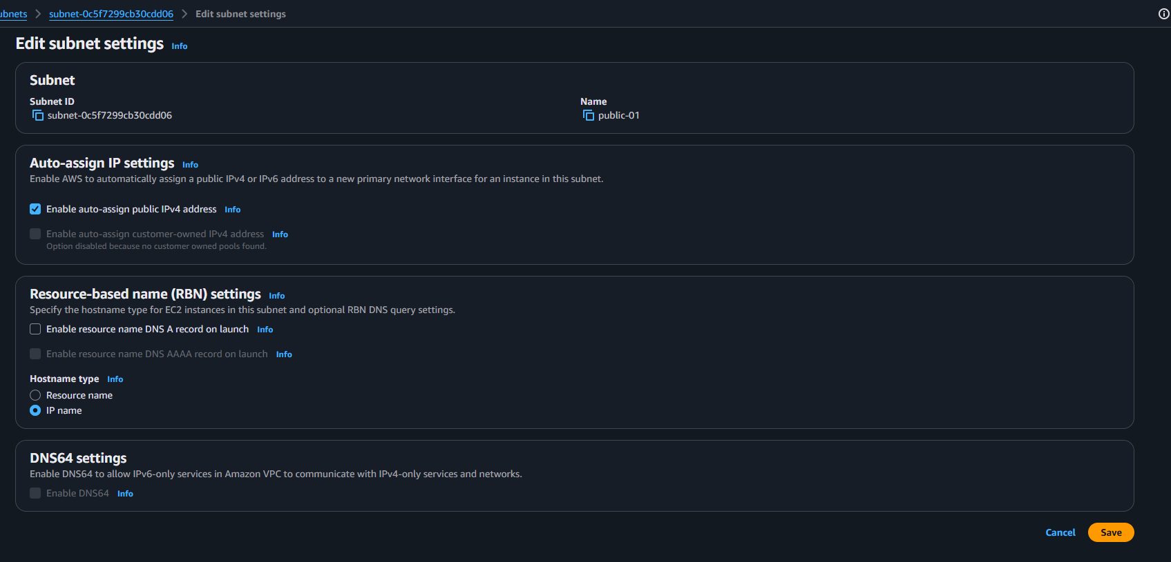
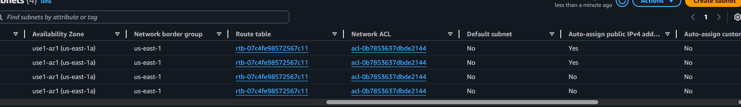

4 :Add 2 private subnets in private route table.
Ans: first need to create one new route table and save for private subnets 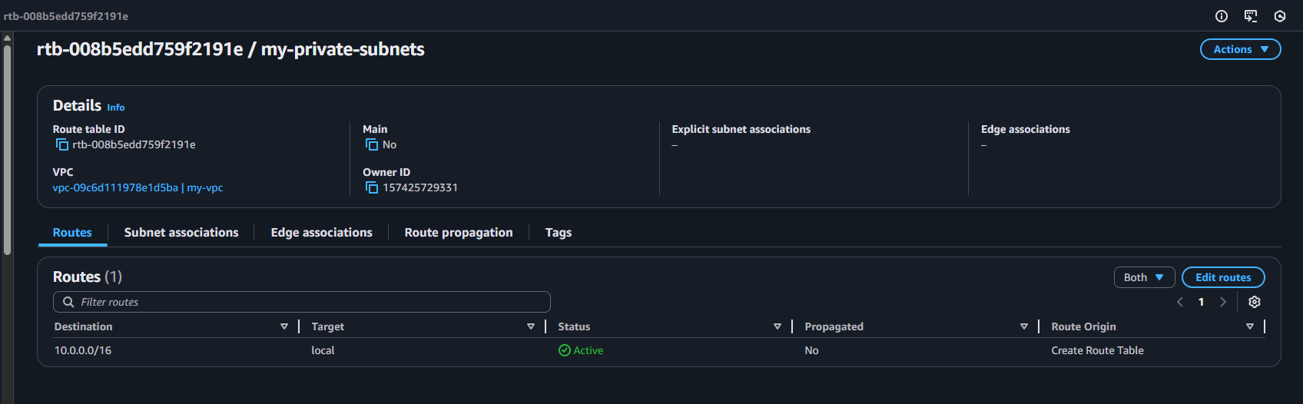 once it got created go for subnets and select private subnets click on route table and assign private route table to subnet and save it 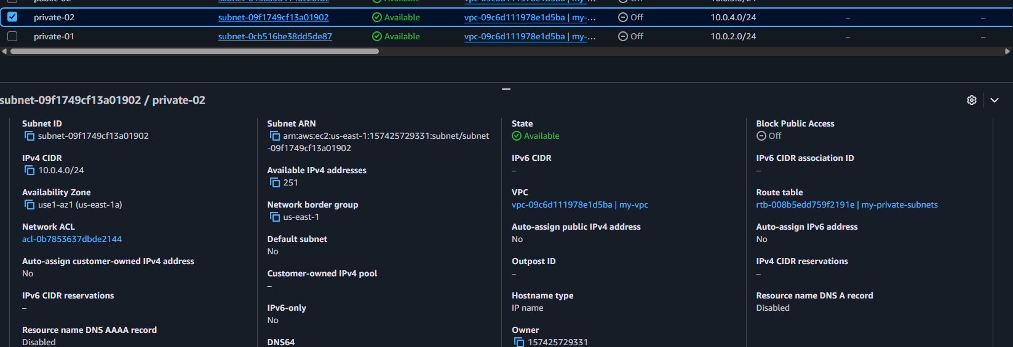

5 :Add 2 public subnets in public route table.
Ans: Default route table is been created then we can rename the route table and save it then select on public subnets and click on route table and then select for edit route table for association and add public route table and save it 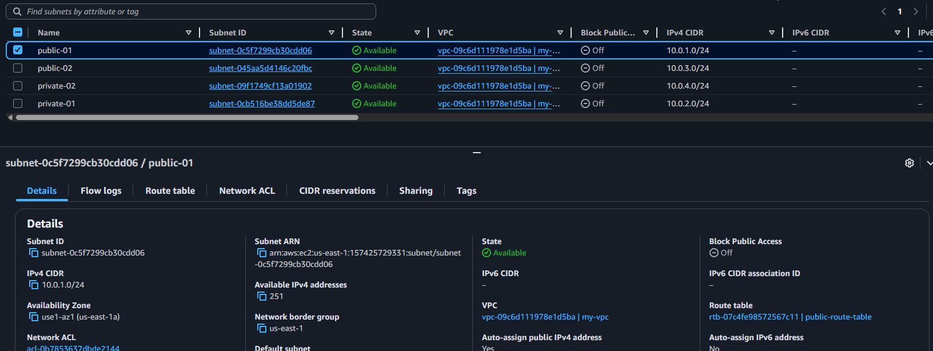

6 :Public route table will have the routes to internet and local.
Ans: to able to add public route table in internet and local need to go internet gateway and create one internet gateway and attach to vpc instance and save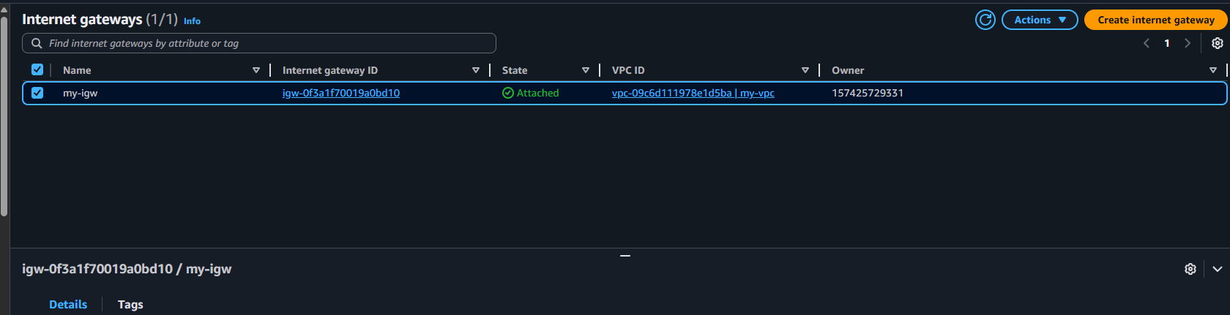 once it got saved then need to click on route table and select the public subnet and click on edit rules and add new rule for internet gateway and save it 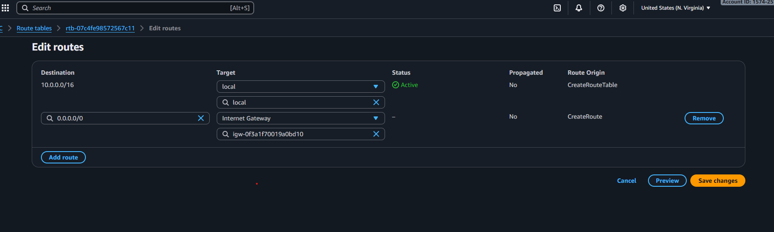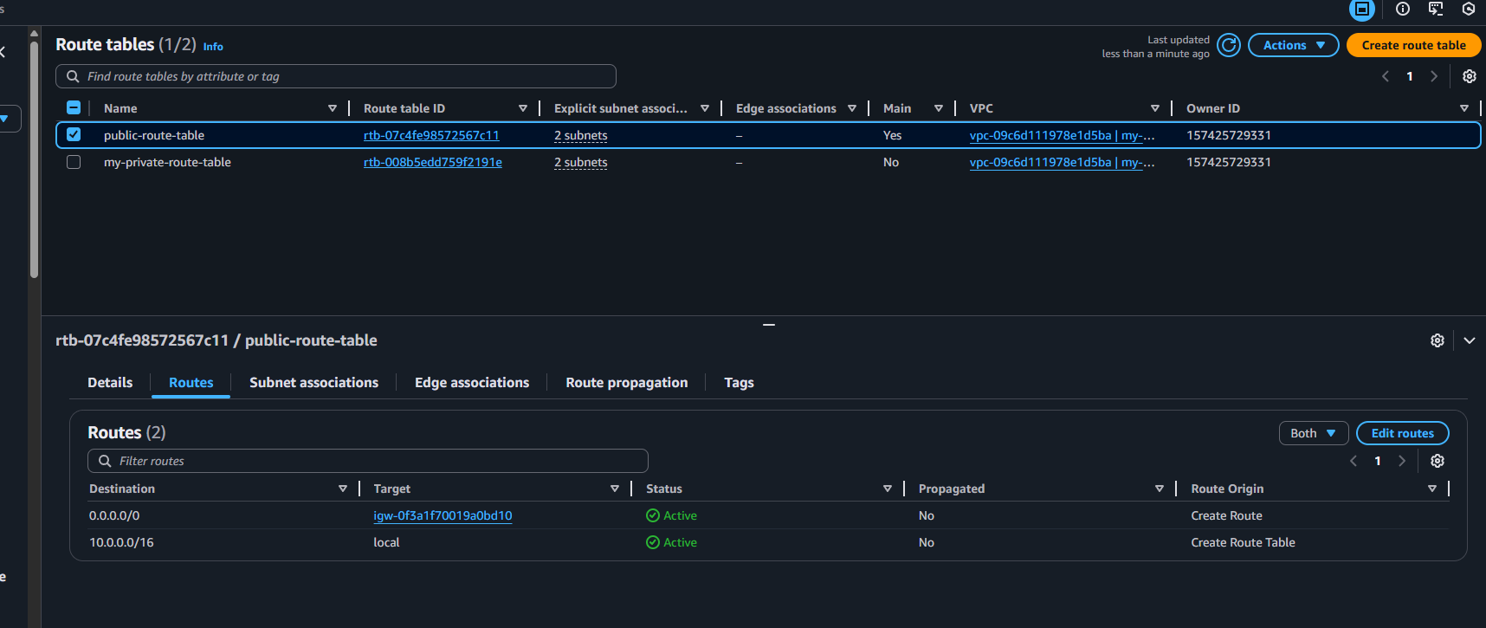

7 :Create EC2 in public subnet with t3.micro and install PHP.
Ans: First need to search for ec2 services and click on launch instance type the name of instance and select the image and select the key pair click on edit network settings and select the vpc and subnet as public and launch the instance 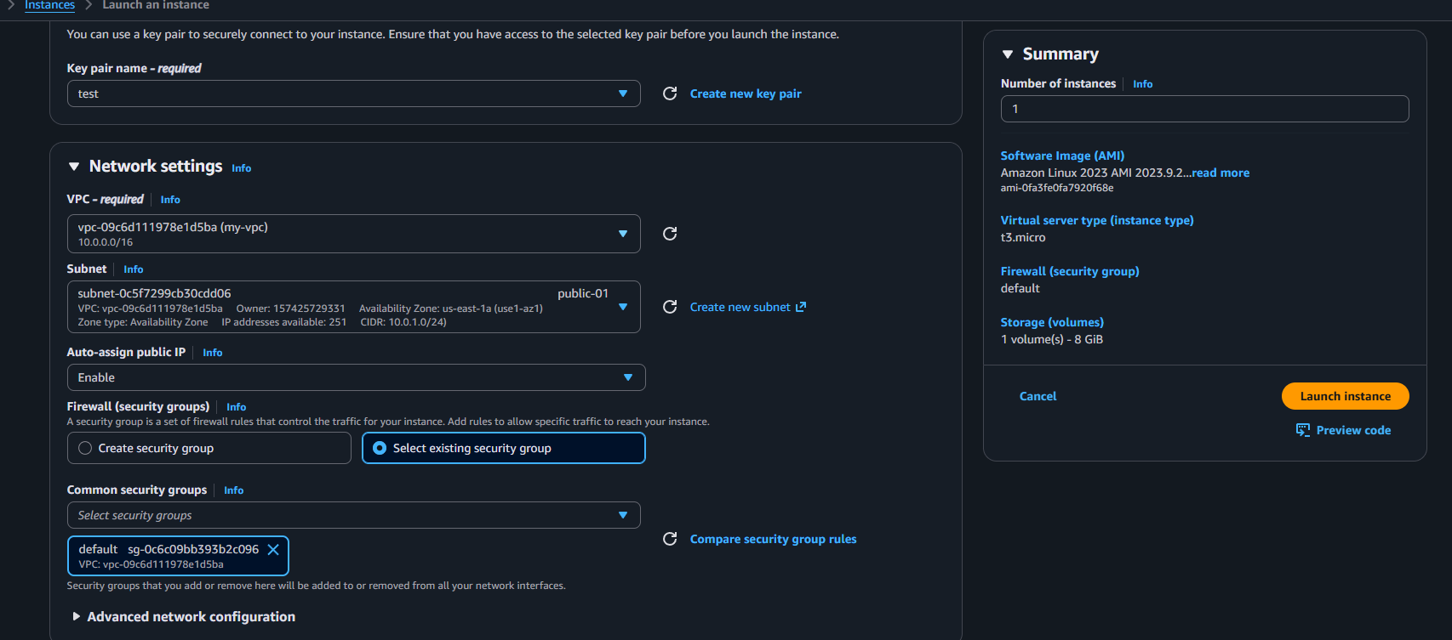
Once it got launch click on security groups and edit the rules and add new rule and select all traffic and ipv4 and save the file then open gitbash and run the command to connect(ssh -i privatekey.pem ec2-user@public-ip) 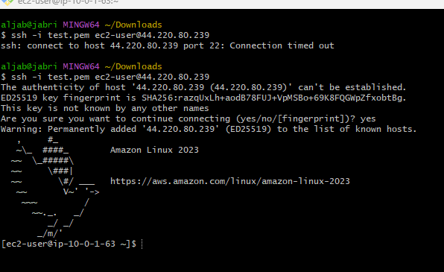
Once it connect change to root and run the command (sudo yum update) and install php (sudo yum install php -y) 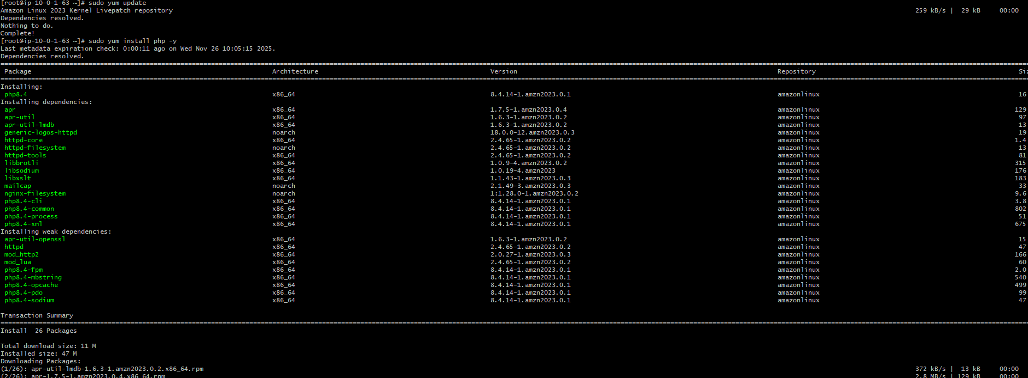
then check the version by using the command of (php -v)
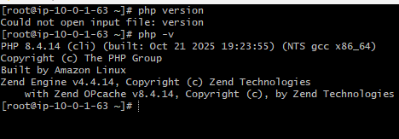
once it get install (sudo amazon-linux-extras enable php) then check in browser with port no:80
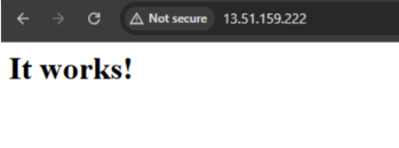

8 :Configure NAT gateway in public subnet and connect to private instance.
Ans: first need to create a net-gateway once select public subnet and click on allocate ip and click on create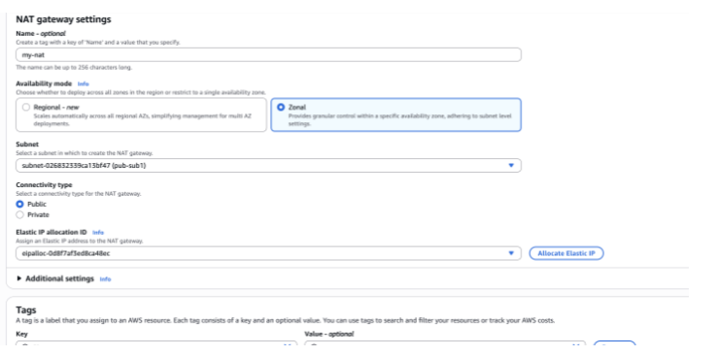
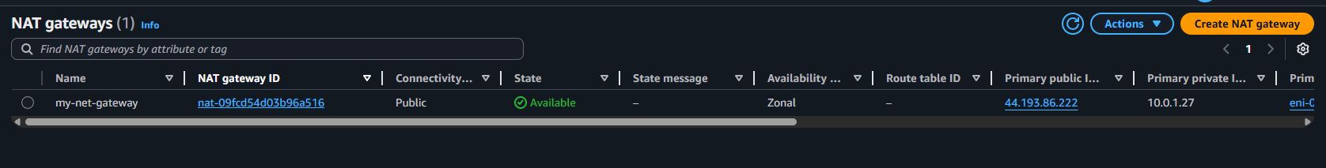

Then go for route tables and select private route and click on routes and click on edit rules and add new rule and save it 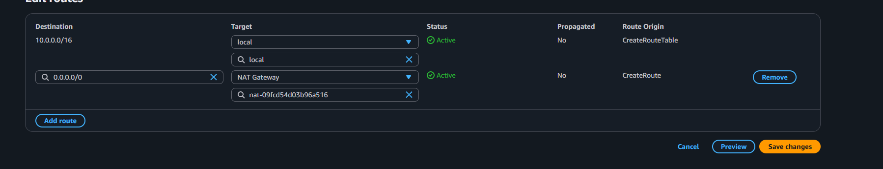
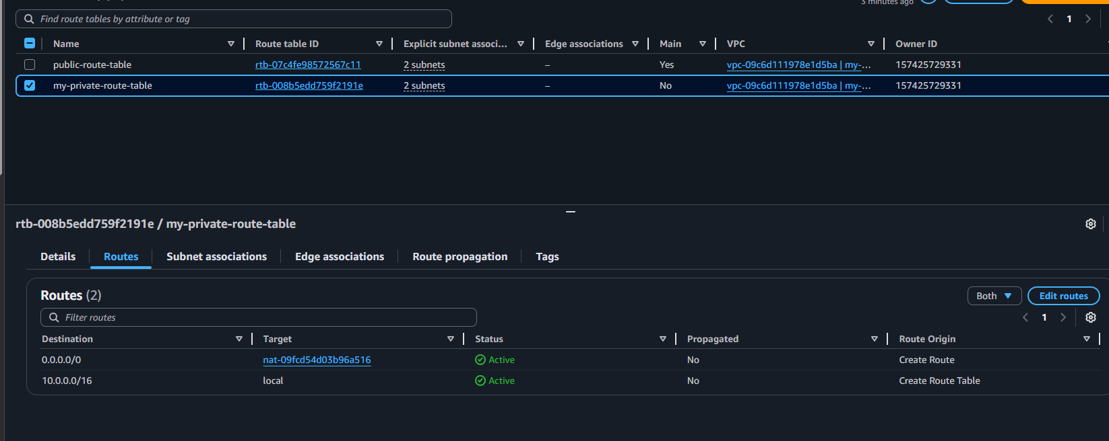
Then need to launch instance with public and private instance in aws ec2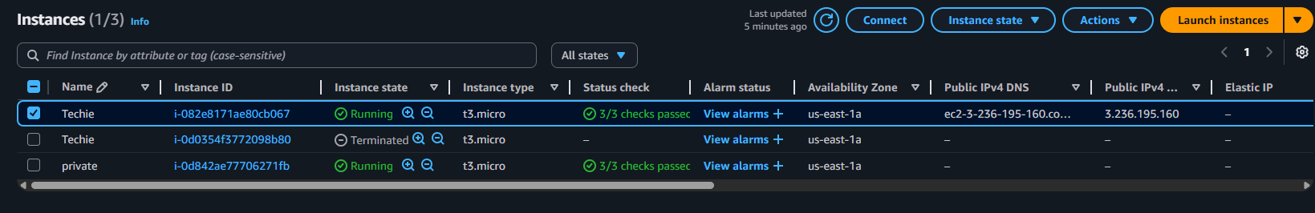
Then open git and run the command to (cat .pem key)and connect to public remote server with command of ssh -I privatekey.pem ec2-user@public ip and once it got connect create a new file and copy the cat.pem and paste in new file and save 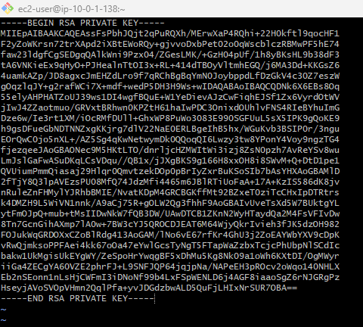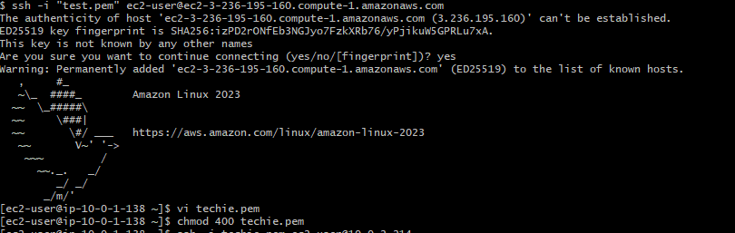once it got saved now need to connect with private subnet use the command (ssh -i new file.pem ec2-user@privateip)it will get connect check internet is working not entre the command ping any domain name 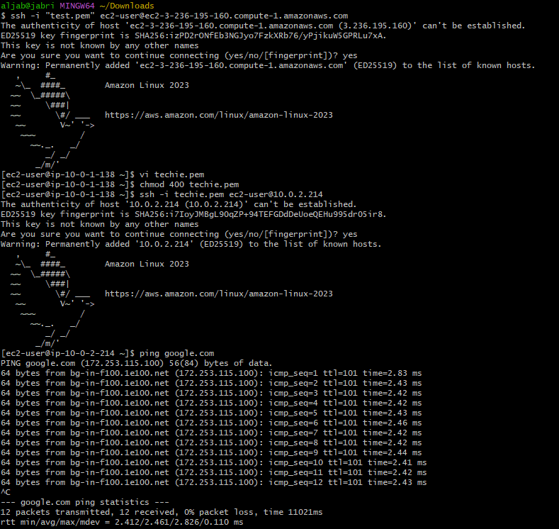

9 :Install Apache Tomcat in private EC2 and deploy a sample app.
Ans: first need to install java by using command of (yum update) then (sudo yum install java-17) 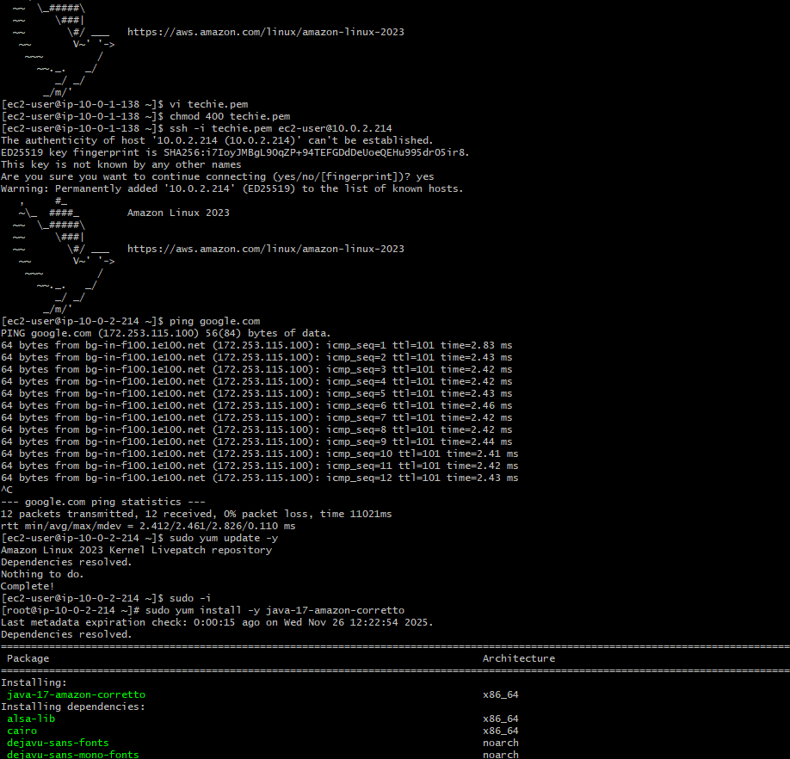
Once the java is been installed check the version and change the directory to opt (cd opt) and run the command (wget paste link of tomcat) once its get downloaded extract the file(tar xzf filename) and rename it (mv old filename new filename) 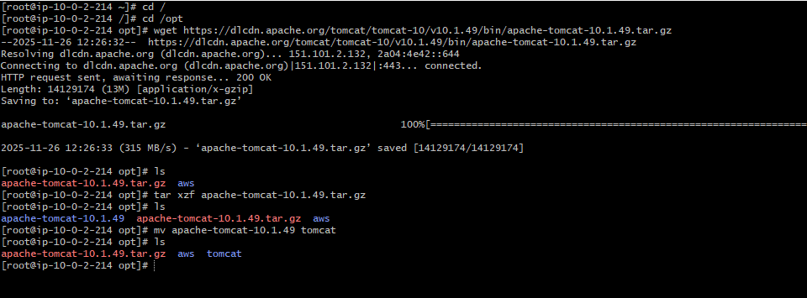
Then move to tomcat direcotry and go to bin run the command to start (./startup.sh)and tomcat sevice is been started 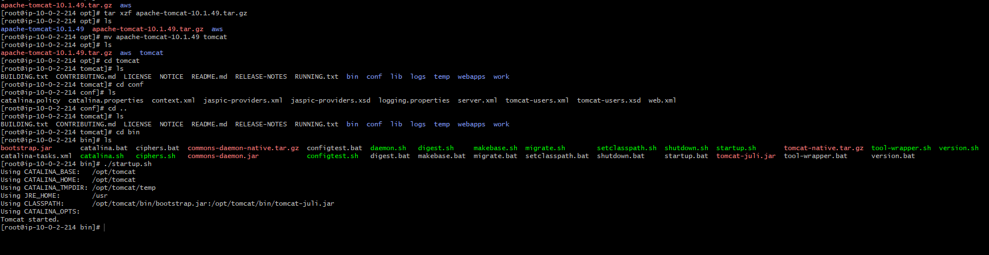
Check through the curl command (curl private ip and portno :8080) 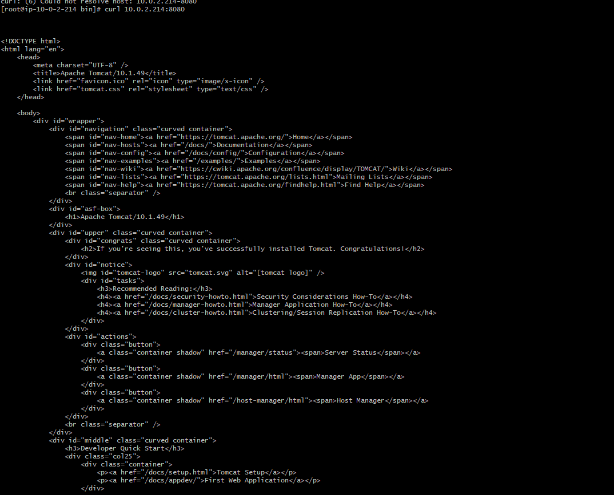

10 : Configure VPC flow logs and store the logs in S3 and CloudWatch.
Ans: create 2 flow logs of cloud watch and s3

S3:
First select the vpc and click flow logs and create a flow log and entre the flow logs name and enter the s3 bucket id there will be an option to create bucket and enter the bucket name and type will be general then
select ACLs enabled unselect the Block all public access Acknowledge and cerate a bucket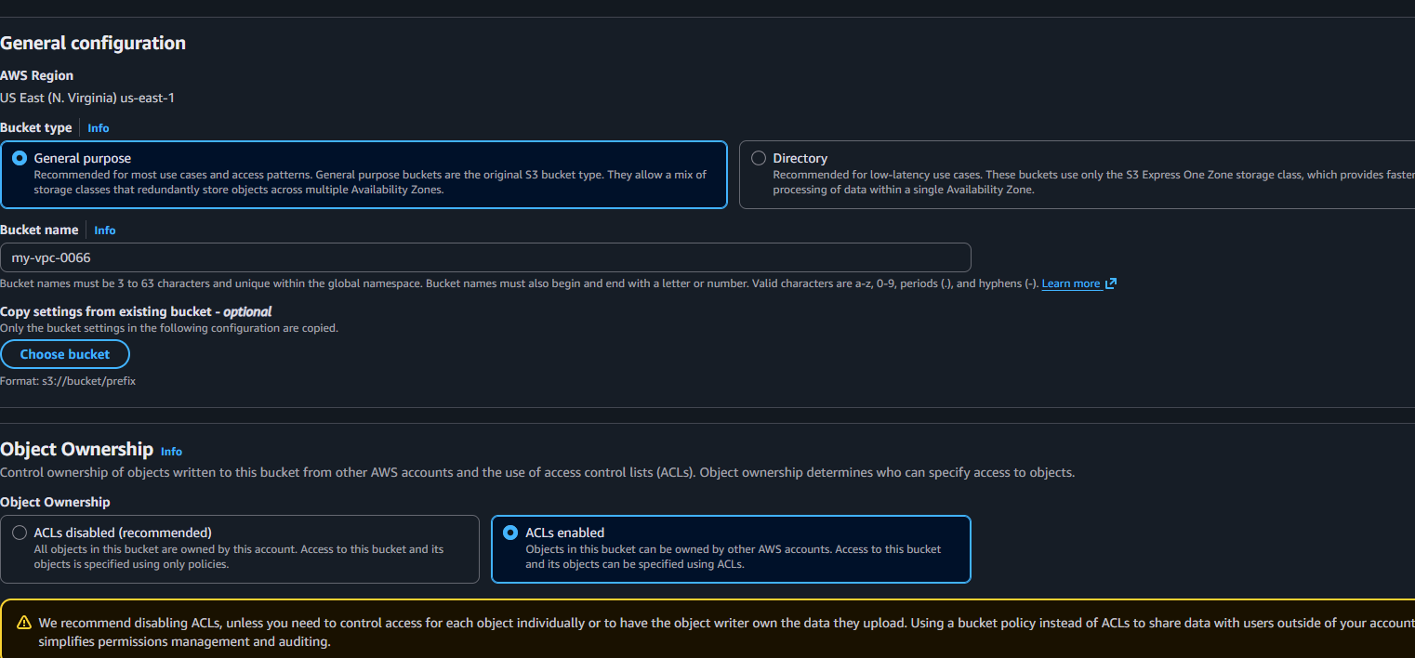 once it got created select the bucket and click properties to copy the ARN name 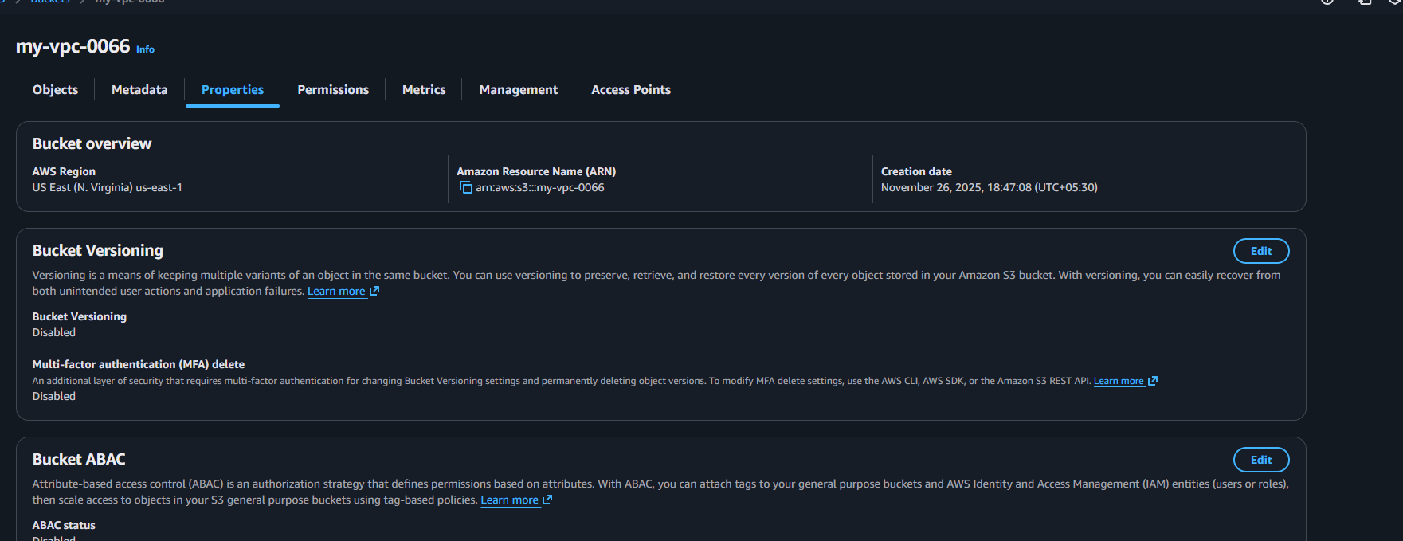

Now go back to flow logs and entre the bucket id 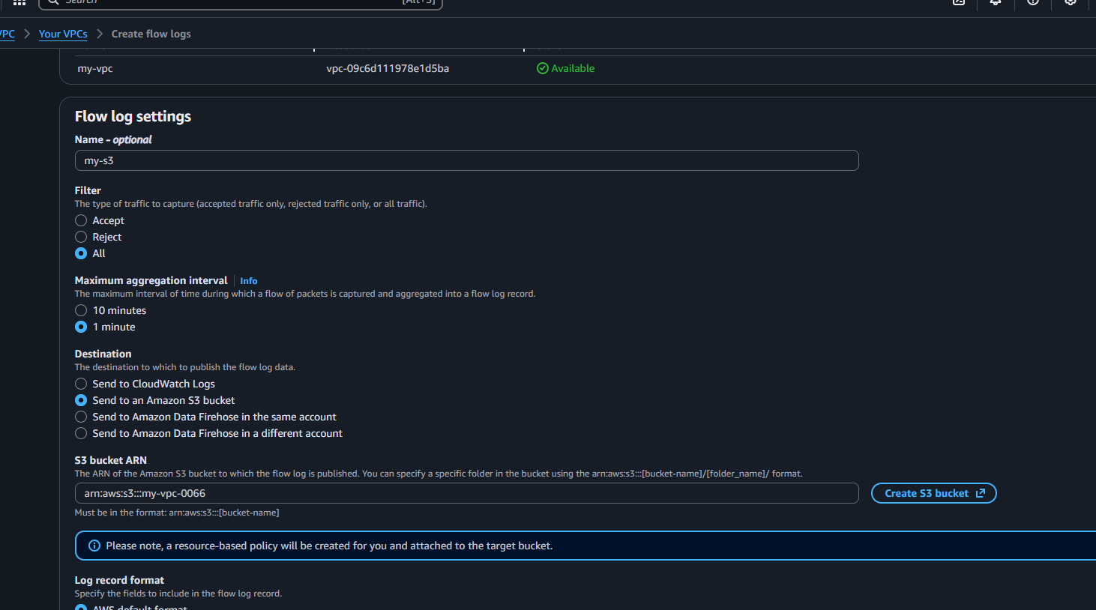
Then create flow logs and click on flow log id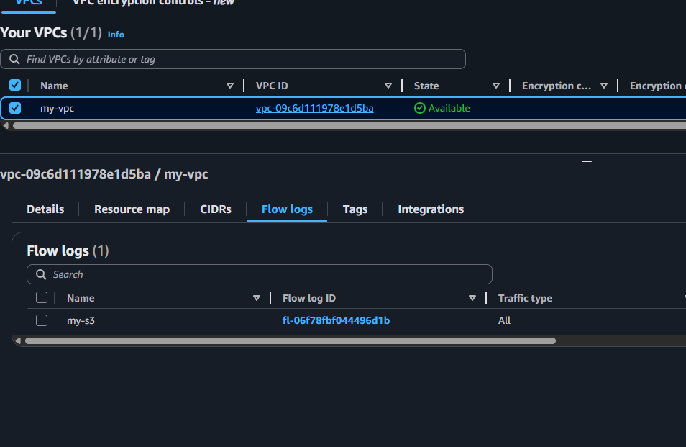

Then need to click on flow log id it will redirect to destination click on destination name 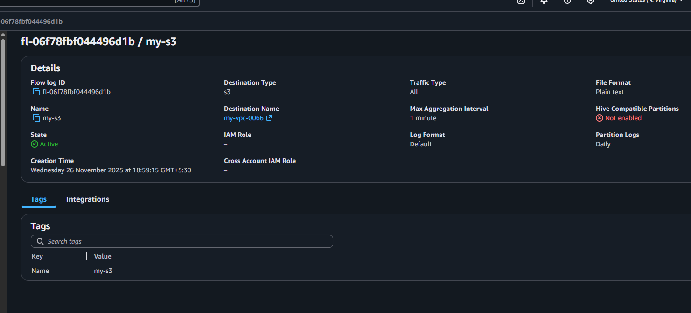

And last one we can see the log files 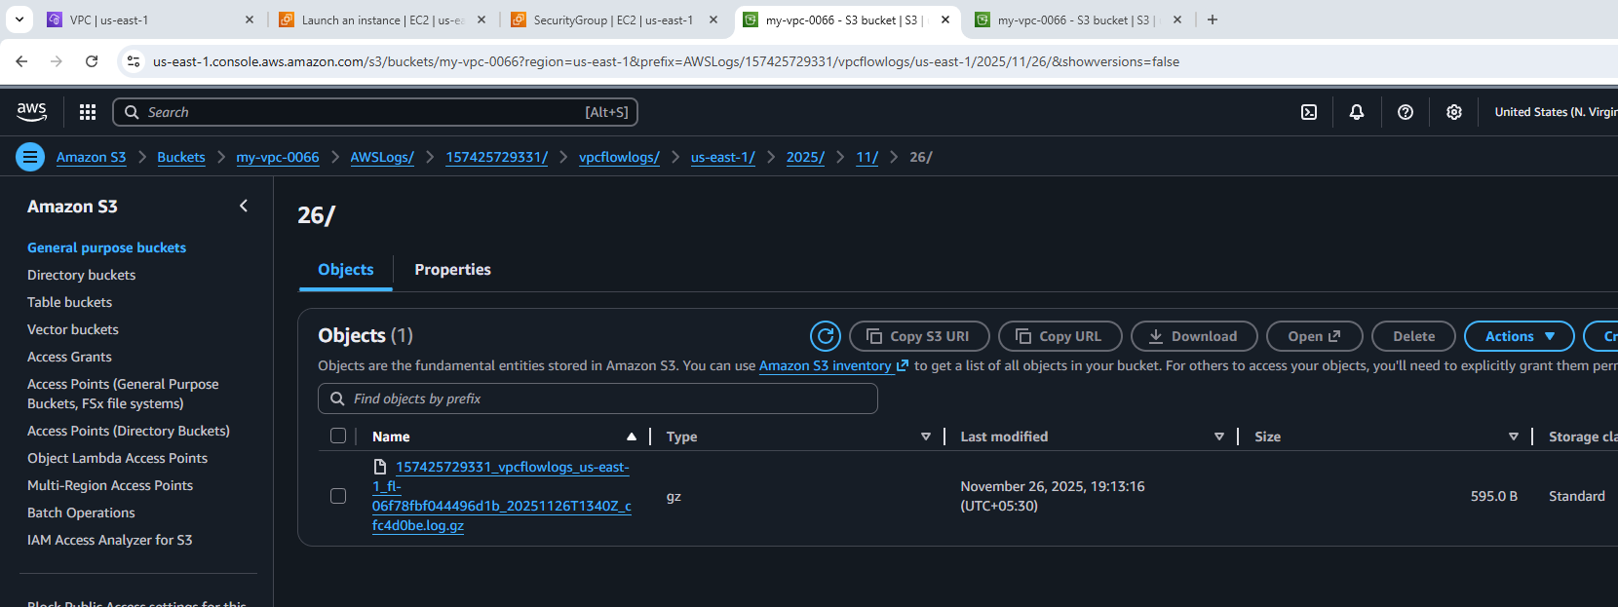
Then we can check and download the log files 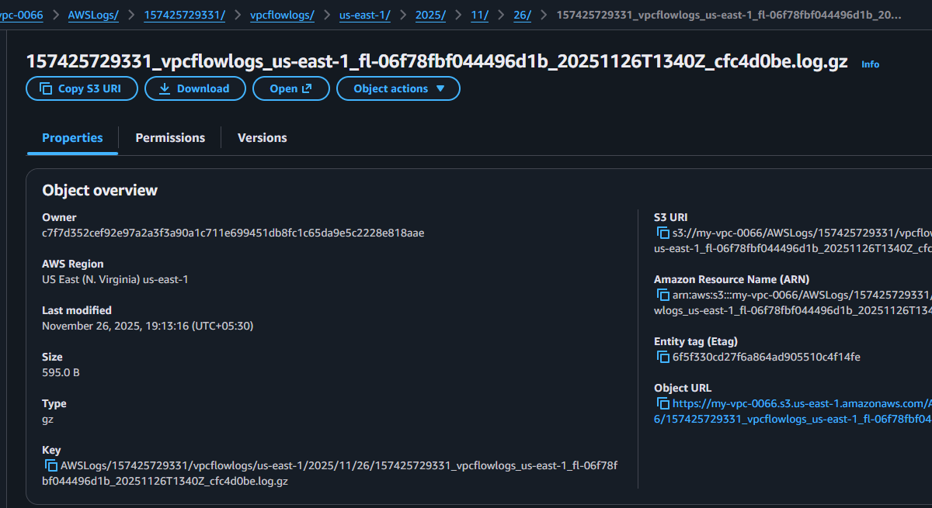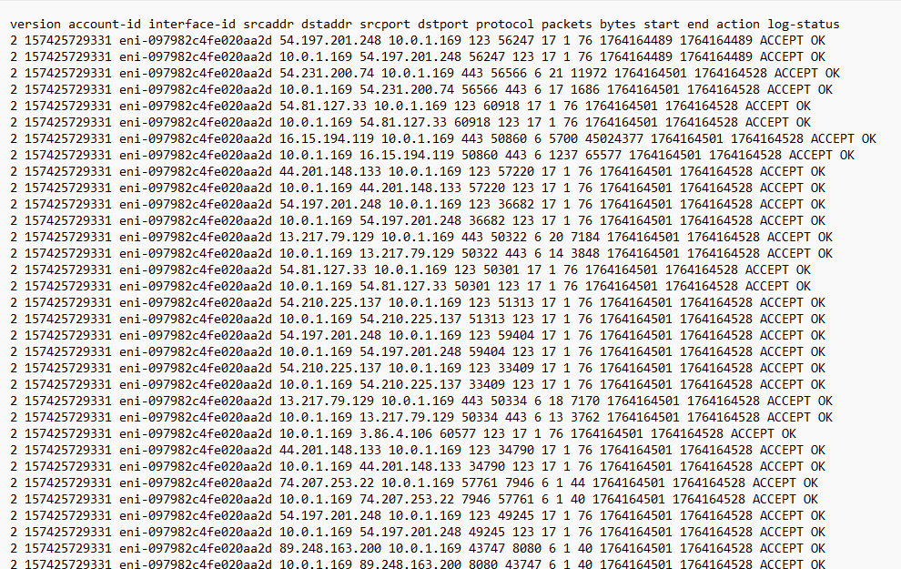

CloudWatch: Now first need to search for cloudwatch in aws console and create a log group 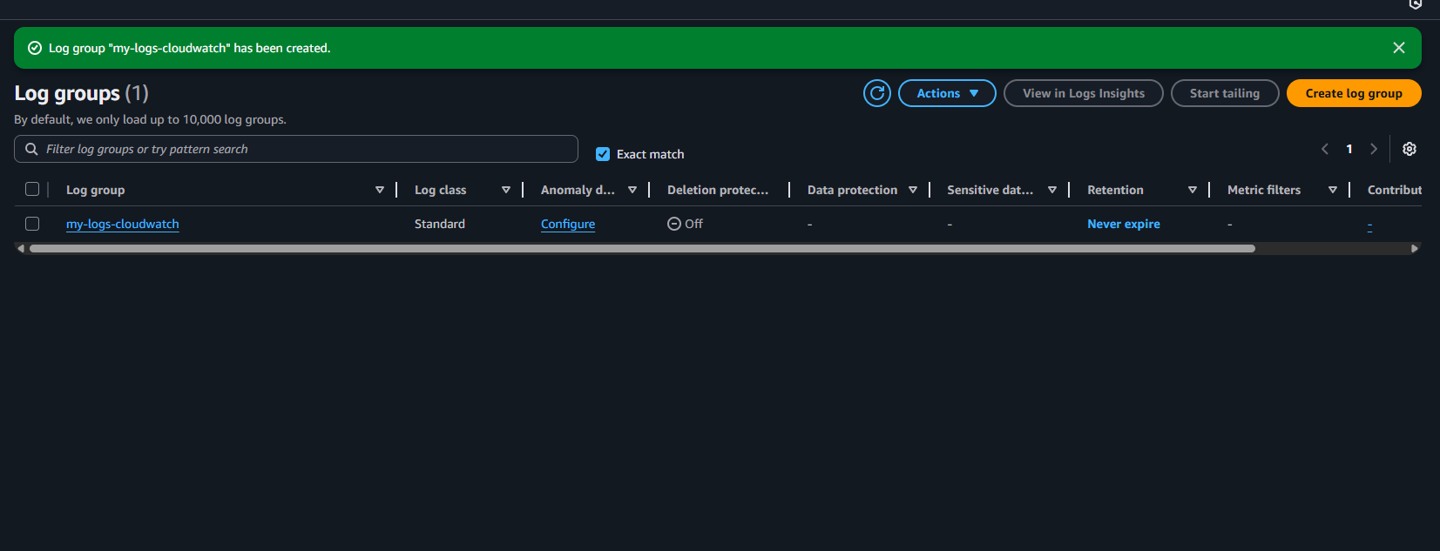
Once it got created copy the ARN name and click on flow logs and create flow logs with cloudwatch 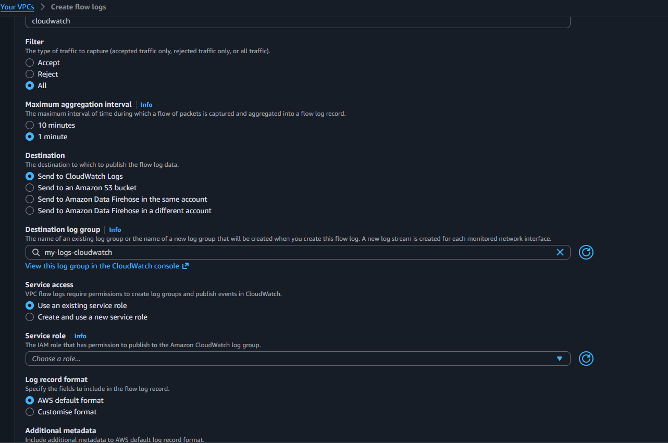
And need to add a role so open the iam and create a policy and save then create a custom trust policy and script and save the role 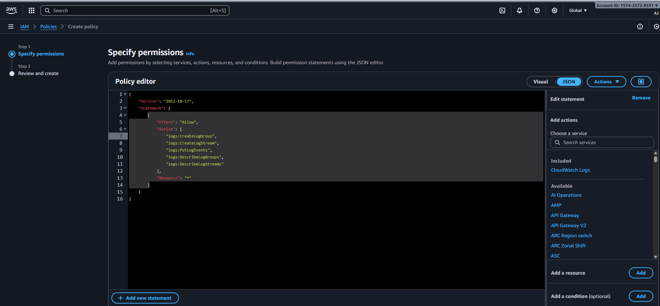 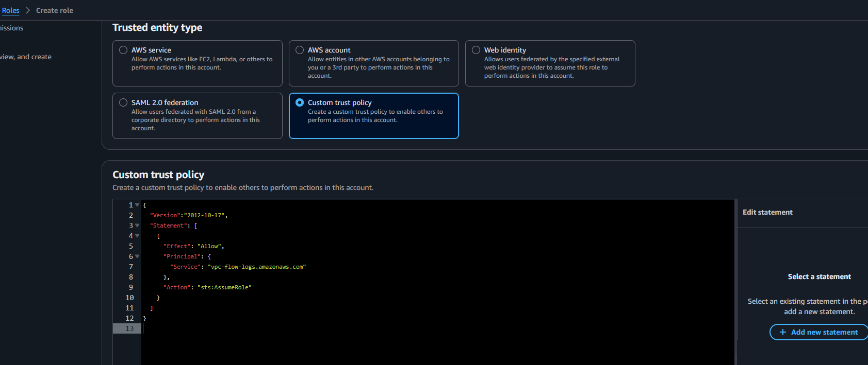
Then save the role and check it got saved 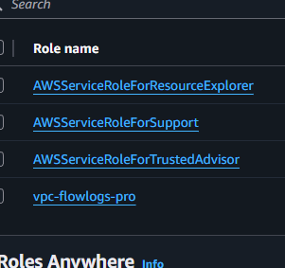
Then go for vpc flow logs and select this role and create flowlogs for cloudwatch 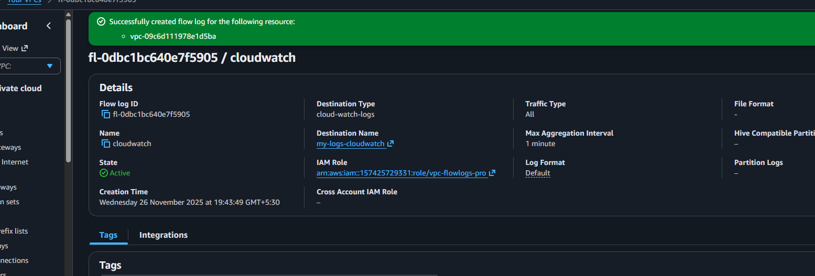
Once it got created visit to cloud watch and click on log groups and check 